# **Issues in the design of Code Generator**

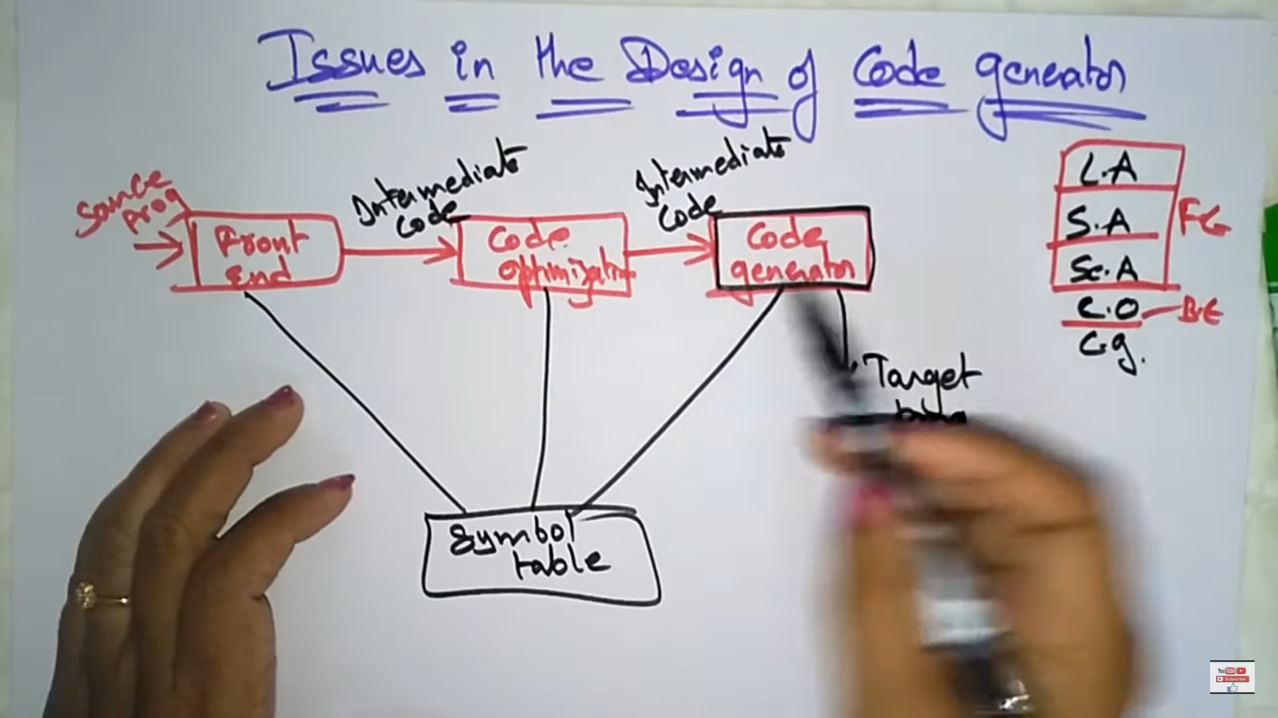

## **Issues in the design of code generator**

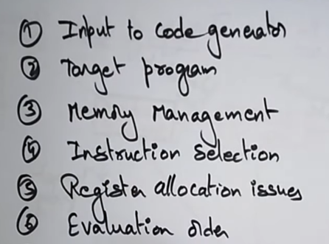

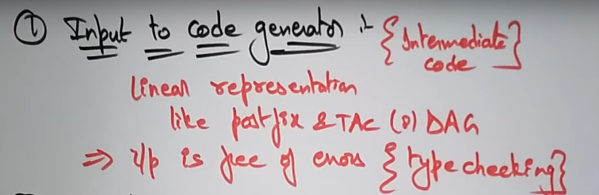

Intermediate code generator 🡪 Input to the code generator.  
Inputs are linear representation and can be post-fix, Three Address Code(TAC) and Directed Acyclic Graph (DAG).  
Inputs must be free of errors.

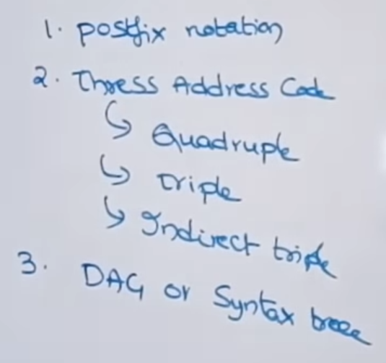

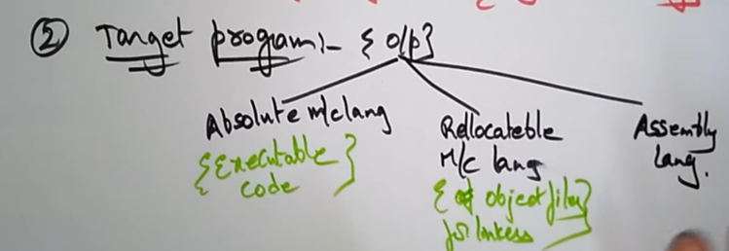

Target program is generally the output

Absolute machine Language 🡪executable code (.exe)  
Re-locatable machine Language 🡪 object files for linkers and loaders  
Assembly Language 🡪 facilitates debuggers

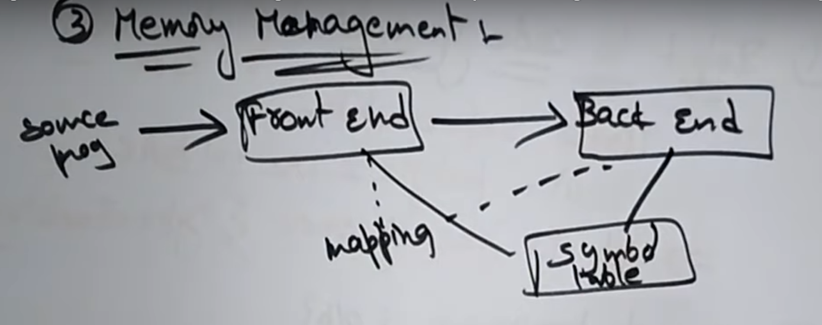

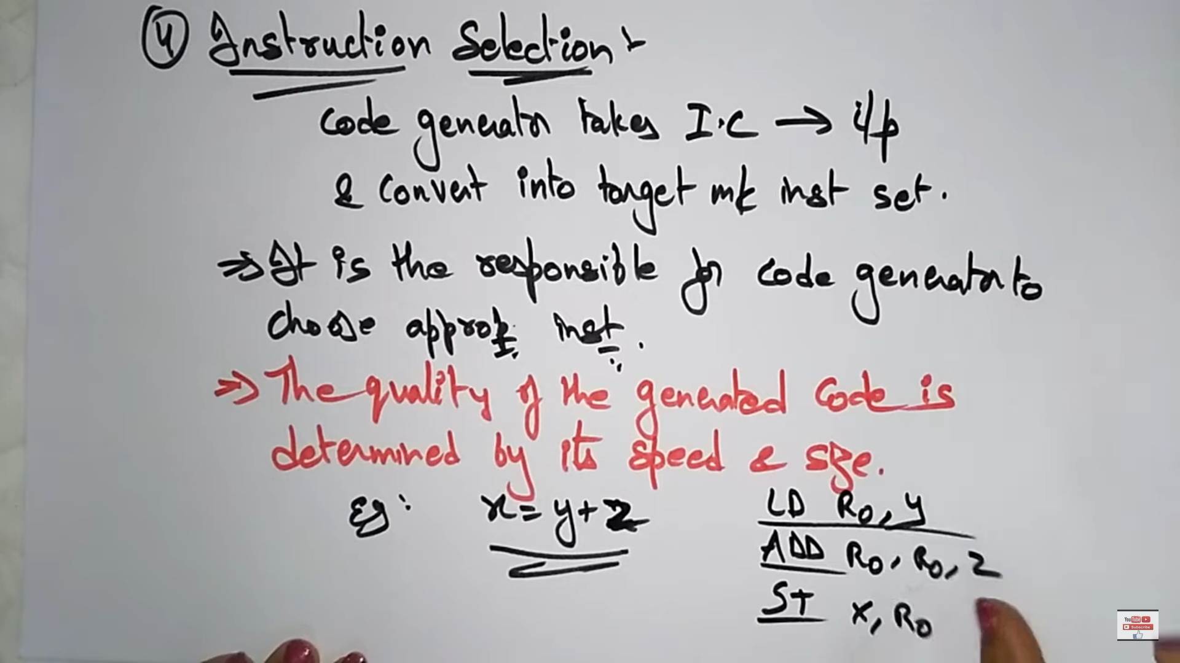

Load, Add and Store are the instructions selected to perform x=y+z.

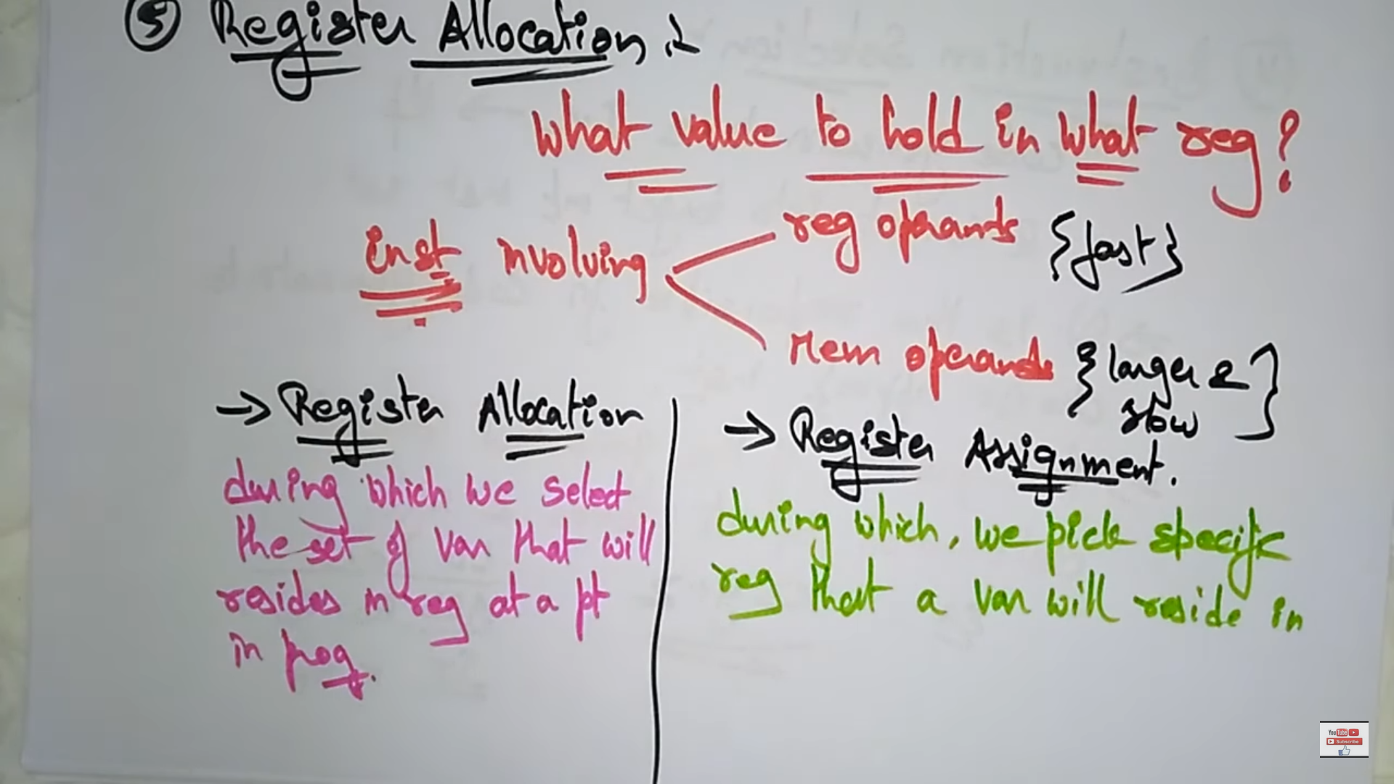

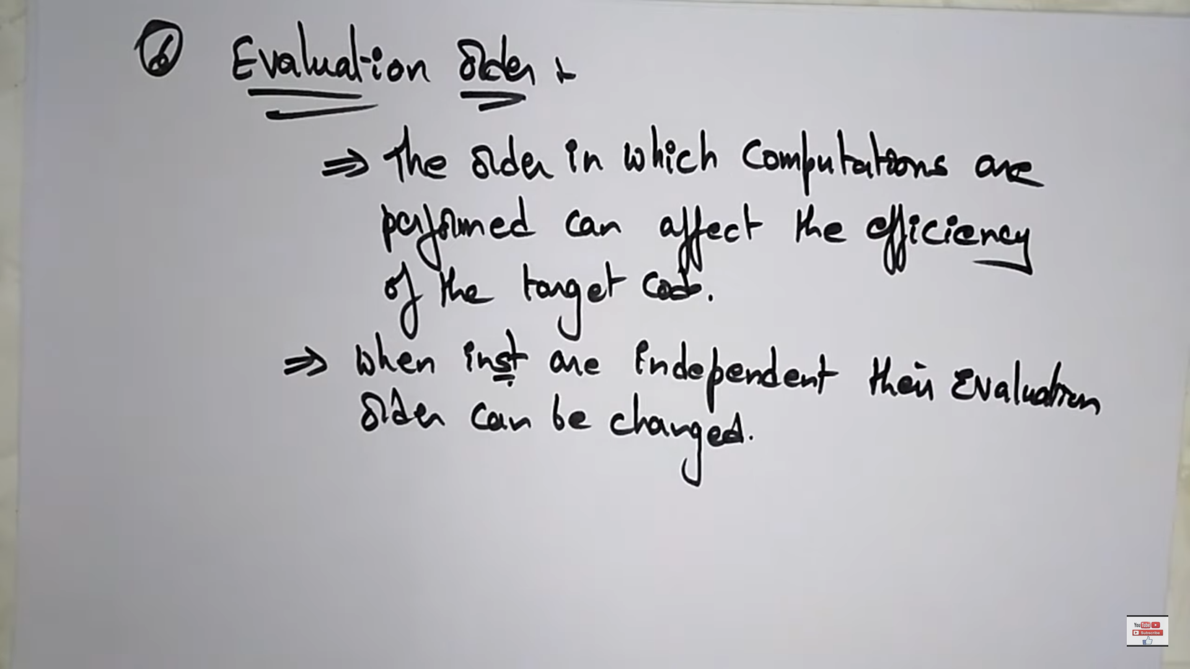

# **Peephole Optimization**

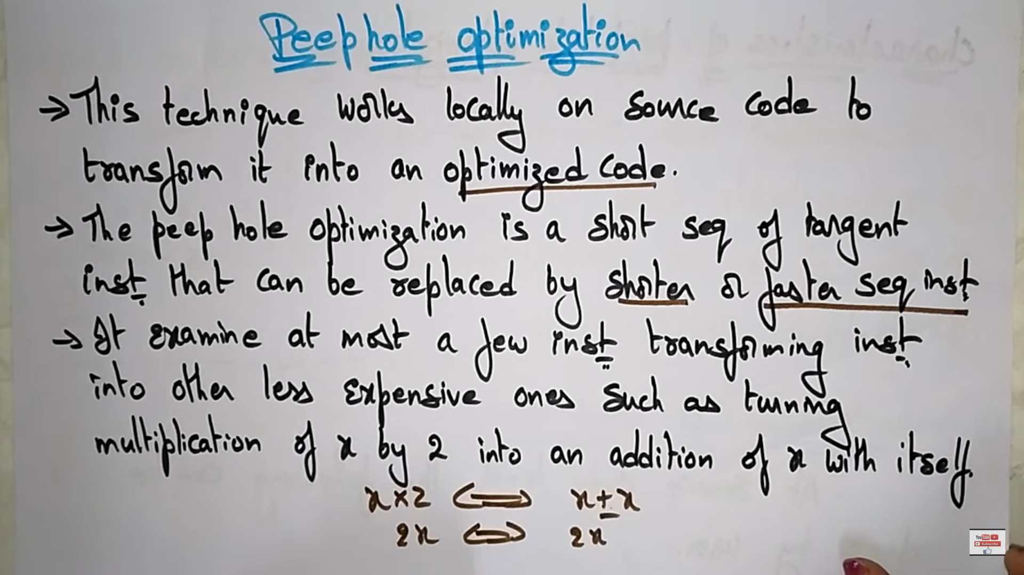

## **Characteristics**

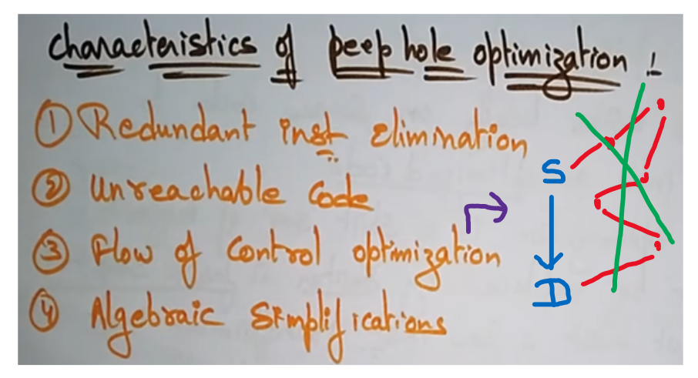

Instead of reaching from source to destination directly. We don’t want to go here and there and then reach destination , we can also optimize that flow.

## **Redundant Instruction Elimination**

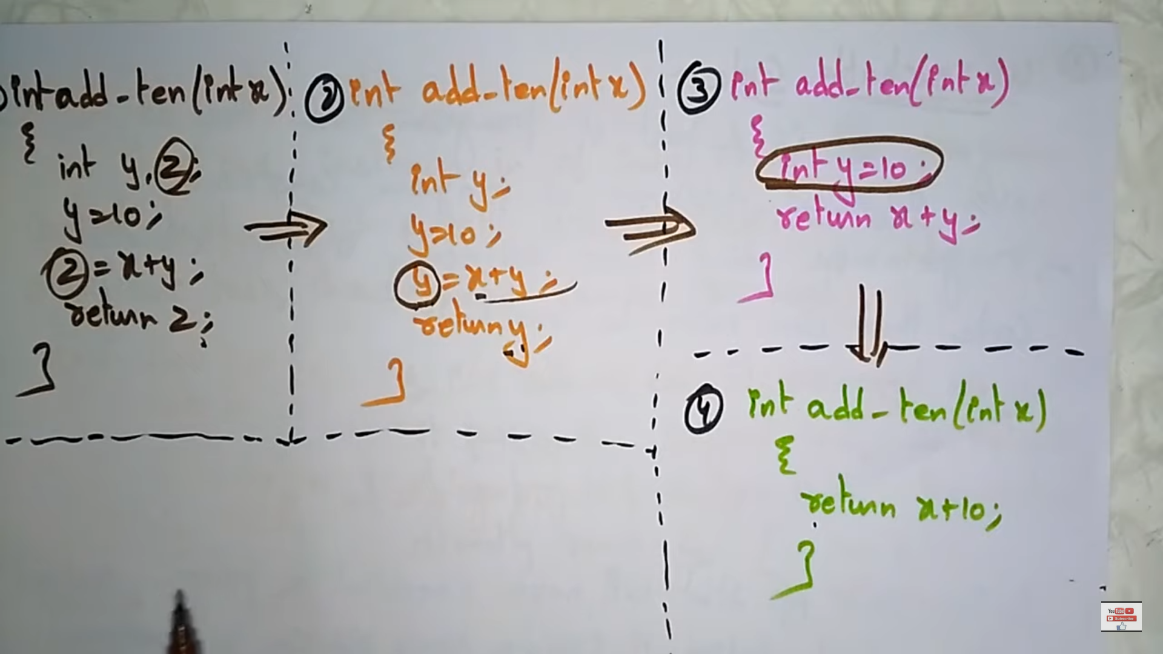



Though all the code provide the same meaning, the 4th one is finest and optimized.

## **Un-reachable Code**

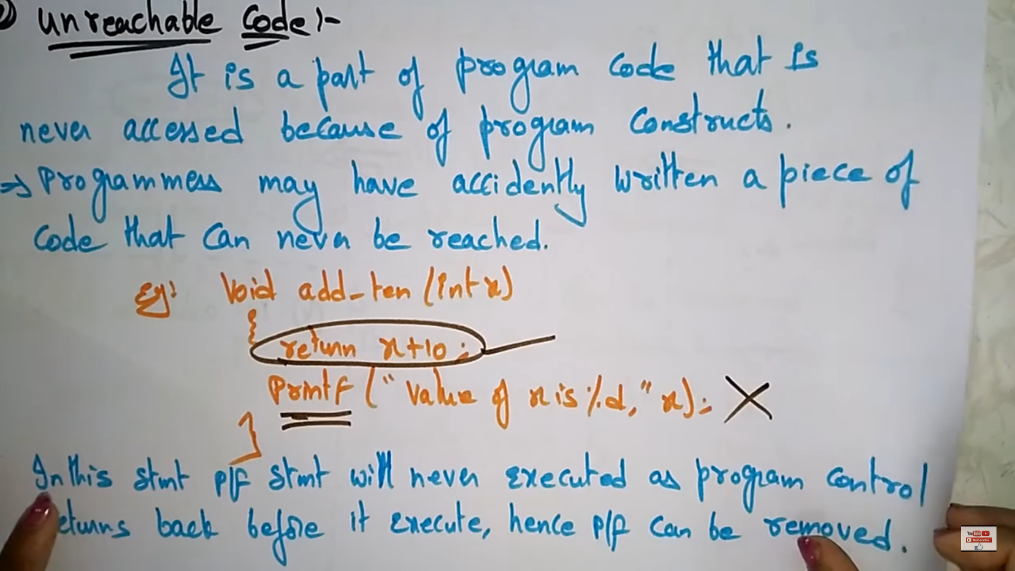

## **Flow of Control Optimization**

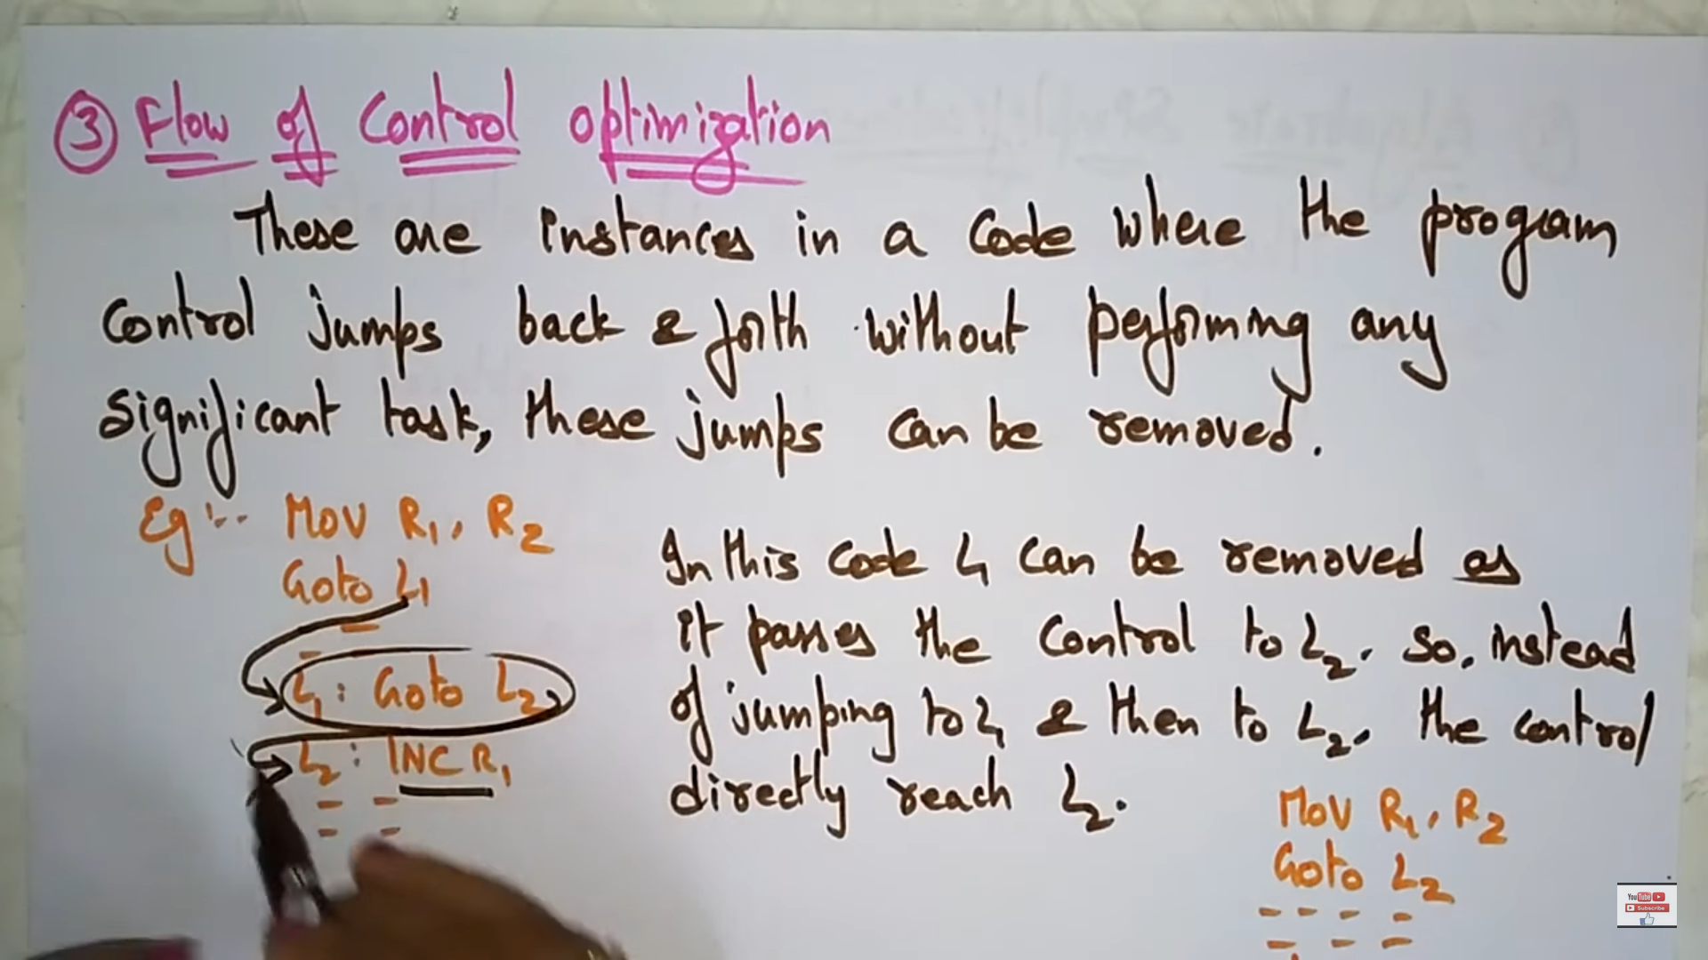



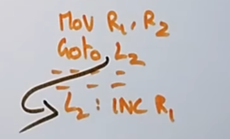



Instead of 1, 2 is better.

## **Algebraic Simplification**

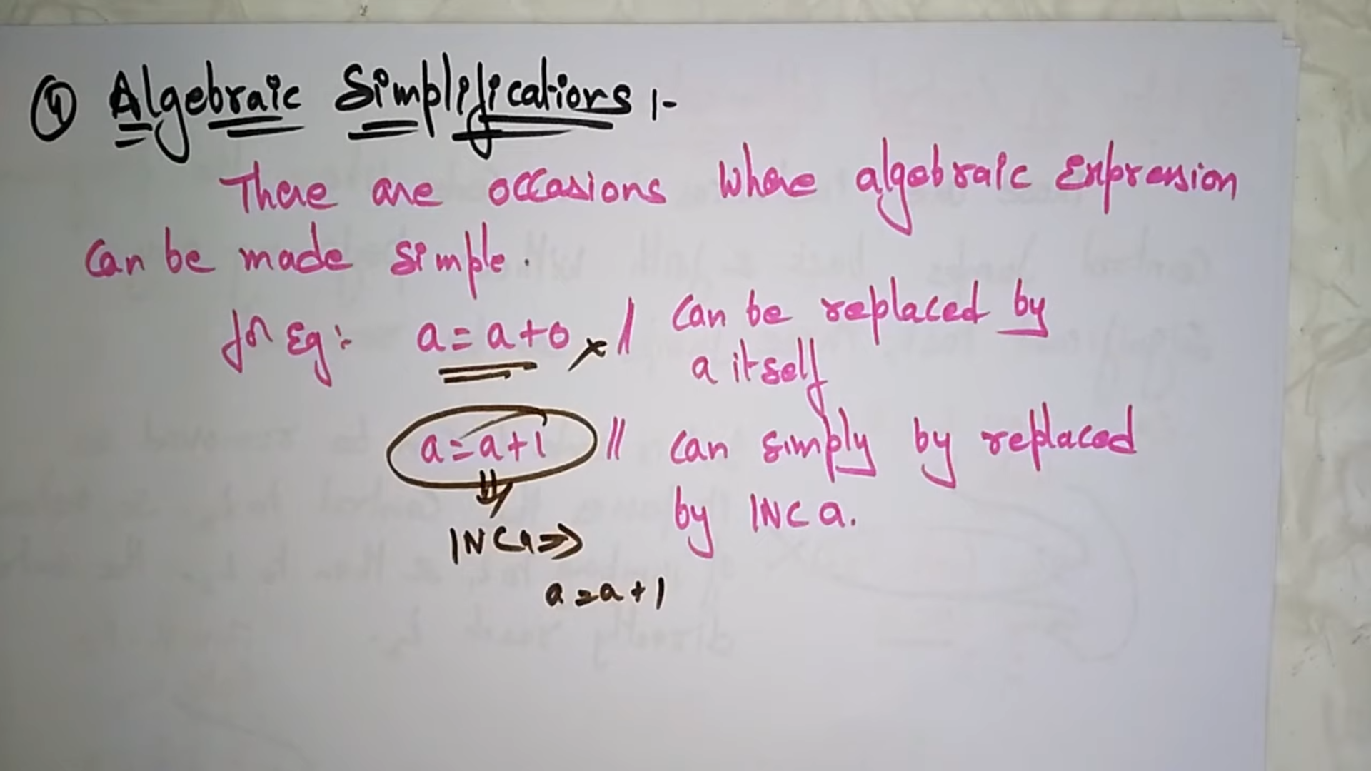

There is no point of adding 0 + number.   
Instead of a = a + 1, simply we can write INC a.